TEACHER:MWALE CHIPO

KENNETH KAUNDA SECONDARY SCHOOL DESIGN AND TECHNOLOGY DEPARTMENT
LESSON PLAN

SUBJECT: DESIGN AND TECHNOLOGY CLASS:…… … DATE:……/……./20…. DURATION:………….
BOYS:…………………… GIRLS ………………………………………. TOTAL OF PUPILS…
TOPIC: PLANE FIGURES SUBTOPIC: REDUCTION AND ENLARGEMENT OF PLANE FIGURES LEARNING OUTCOMES LSBAT
- To Reduce and enlarge plane figures

RATIONALE
Knowledge: Enlargement of plane figures by linear and area ratios.
Skills: Accuracy in enlarging and reducing plane figures
Values. Appreciation of reduction and enlargement of plane figures in designing.
TEACHING AIDS
……………………………………………………………………………………………………………………………………………

PART | LESSON CONTENT | METHODOLO GY | LEARNER ACTIVITY
introductio n | - Recap on the previous lesson | Questions and answers | Provide answers
Developme nt | ENLARGEMENT OF PLANE FIGURE  - An object is enlarged when all of its dimensions changed in the same ratio.  TO ENLARGE THE GIVEN TRIANGLE USING THE RATIO 5:3  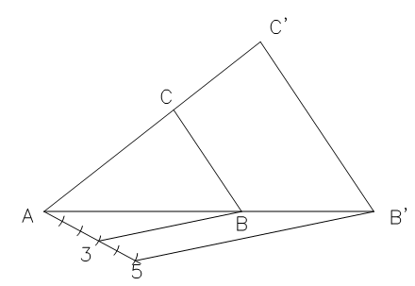  - Draw the given triangle ABC  - Divide AB into 3 equal parts  - Extend AB and AC from A.  - Draw unit 4C’ parallel to BC.  - Draw C’D’ parallel to CD.  - Draw B’C’ parallel to BC to complete the required triangle
Application | CLASS EXERCISE  - Construct the triangle given that AB=40, AC= 50 and BC=45  - Construct a rectangle equal in area to the given triangle. Ratio 5:2 | Questions And Answers | Provide answers
Conclusion | - Recap on the main steps and points | V/E

TEACHER:MWALE CHIPO

KENNETH KAUNDA SECONDARY SCHOOL DESIGN AND TECHNOLOGY DEPARTMENT
LESSON PLAN

SUBJECT: DESIGN AND TECHNOLOGY CLASS:…… … DATE:……/……./20…. DURATION:………….
BOYS:…………………… GIRLS ………………………………………. TOTAL OF PUPILS…
TOPIC: PLANE FIGURES SUBTOPIC: ENLARGEMENT OF PLANE FIGURES LEARNING OUTCOMES LSBAT
- To Reduce and enlarge plane figures

RATIONALE
Knowledge: Enlargement of plane figures by linear and area ratios.
Skills: Accuracy in enlarging and reducing plane figures
Values. Appreciation of reduction and enlargement of plane figures in designing.
TEACHING AIDS
……………………………………………………………………………………………………………………………………………

PART | LESSON CONTENT | METHODOLO GY | LEARNER ACTIVITY
introductio n | - Recap on the previous lesson | Questions and answers | Provide answers
Developme nt | ENLARGEMENT OF PLANE FIGURE  TO ENLARGE THE GIVEN PENTAGON POLYGON USING THE RATIO 5:3  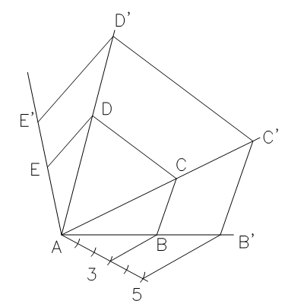  - Draw the given plane figures  - Extend line AB.  - Draw line of any convenient length and angle from A and Mark 5 equal units of any convenient length from A.  - Join 3 and B and draw a parallel line at point 5 to 3B.  - Radiate lines from A through C, E and D.  - Draw B’C’ parallel to BC. Draw C’D’ parallel to CD. Draw E’D’ parallel to ED.
Application | CLASS EXERCISE  - Construct, full size, the polygon ABCDE given lengths of the sides to be; Base line AB = 35, BC = 30, CD = 20, DE= 35, AD = 30, and DAB = 900, ABC=1050.  - Construct a similar figure with the sides increased in the ratio of 5:3. | Questions And Answers | Provide answers
Conclusion | - Recap on the main steps and points | V/E

TEACHER:MWALE CHIPO

KENNETH KAUNDA SECONDARY SCHOOL DESIGN AND TECHNOLOGY DEPARTMENT
LESSON PLAN

SUBJECT: DESIGN AND TECHNOLOGY CLASS:…… … DATE:……/……./20…. DURATION:………….
BOYS:…………………… GIRLS ………………………………………. TOTAL OF PUPILS… TOPIC: PLANE FIGURES SUBTOPIC: REDUCTION OF PLANE FIGURES LEARNING OUTCOMES LSBAT
- To Reduce and enlarge plane figures

RATIONALE
Knowledge: Reduction of plane figures by linear and area ratios.
Skills: Accuracy in enlarging and reducing plane figures
Values. Appreciation of reduction and enlargement of plane figures in designing.
TEACHING AIDS
……………………………………………………………………………………………………………………………………………

PART | LESSON CONTENT | METHODOLO GY | LEARNER ACTIVITY
introductio n | - Recap on the previous lesson | Questions and answers | Provide answers
Developme nt | REDUCTION OF PLANE FIGURE  TO REDUCE THE GIVEN PENTAGON POLYGON USING THE RATIO 5:3  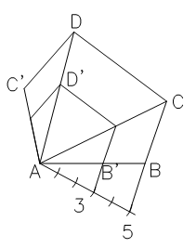  - Draw the given pentagon ABCDE  - Divide AB into 5 equal parts  - Radiate lines from A to the corner C and D.  - Draw unit 4C’ parallel to BC.  - Draw C’D’ parallel to CD.  - Draw D’E’ parallel to DE to complete the reduced figure
Application | CLASS EXERCISE  - Construct, full size, the polygon ABCDE given lengths of the sides to be; Base line AB = 70, BC = 60, CD = 40, DE= 65, AD = 60, and DAB = 900, ABC=1050.  - Construct a similar figure with the sides reduced in the ratio of 3:5. | Questions And Answers | Provide answers
Conclusion | - Recap on the main steps and points | V/E

TEACHER:MWALE CHIPO

KENNETH KAUNDA SECONDARY SCHOOL DESIGN AND TECHNOLOGY DEPARTMENT
LESSON PLAN

SUBJECT: DESIGN AND TECHNOLOGY CLASS:…… … DATE:……/……./20…. DURATION:………….
BOYS:…………………… GIRLS ………………………………………. TOTAL OF PUPILS…
TOPIC: PLANE FIGURES SUBTOPIC: ENLARGEMENT OF PLANE FIGURES LEARNING OUTCOMES LSBAT
- To Reduce and enlarge plane figures

RATIONALE
Knowledge: Enlargement and reduction of plane figures by linear and area ratios.
Skills: Accuracy in enlarging and reducing plane figures
Values. Appreciation of reduction and enlargement of plane figures in designing.
TEACHING AIDS
……………………………………………………………………………………………………………………………………………

PART | LESSON CONTENT | METHODOLO GY | LEARNER ACTIVITY
introductio n | - Recap on the previous lesson | Questions and answers | Provide answers
Developme nt | ENLARGEMENT OF PLANE FIGURE  TO ENLARGE THE GIVEN POLYGON USING THE RATIO 5:3  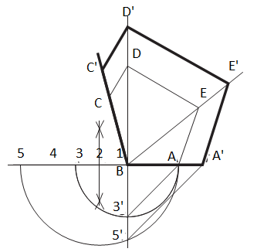  - Draw the given pentagon ABCDE  - Extend AB in both directions and mark 5 equal units of any convenient length from B.  - Draw a semicircle on A3 and A5  - Draw a perpendicular to AB from B to cut the semicircles at 3’5’  - Join A3’ and draw 5’A’ parallel to it.  - Radiate lines from B through E and D.  - Draw A’E’ parallel to AE. Draw E’D’ parallel to ED. Draw D’C’ parallel to DC to complete the required polygon
Application | CLASS EXERCISE  - Construct, full size, the polygon ABCDE given lengths of the sides to be; Base line AB = 35, BC = 30, CD = 20, DE= 35, AD = 30, and DAB = 900, ABC=1050.  - Construct a similar figure with the sides increased in the ratio of 5:3. | Questions And Answers | Provide answers
Conclusion | - Recap on the main steps and points | V/E

TEACHER:MWALE CHIPO

KENNETH KAUNDA SECONDARY SCHOOL DESIGN AND TECHNOLOGY DEPARTMENT
LESSON PLAN

SUBJECT: DESIGN AND TECHNOLOGY CLASS:…… … DATE:……/……./20…. DURATION:………….
BOYS:…………………… GIRLS ………………………………………. TOTAL OF PUPILS… TOPIC: PLANE FIGURES SUBTOPIC: REDUCTION OF PLANE FIGURES LEARNING OUTCOMES LSBAT
- To Reduce and enlarge plane figures

RATIONALE
Knowledge: Enlargement and reduction of plane figures by linear and area ratios.
Skills: Accuracy in enlarging and reducing plane figures
Values. Appreciation of reduction and enlargement of plane figures in designing.
TEACHING AIDS
……………………………………………………………………………………………………………………………………………

PART | LESSON CONTENT | METHODOLO GY | LEARNER ACTIVITY
introductio n | - Recap on the previous lesson | Questions and answers | Provide answers
Developme nt | REDUCTION OF PLANE FIGURE  TO REDUCE THE GIVEN POLYGON USING THE RATIO 3:5  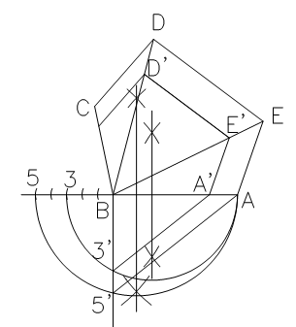  - Draw the given pentagon ABCDE  - Extend AB in both directions and mark 5 equal units of any convenient length from B.  - Draw a semicircle on A3 and A5  - Draw a perpendicular to AB from B to cut the semicircles at 3’5’  - Join A5’ and draw 3’A’ parallel to it.  - Radiate lines from B to E and D.  - Draw A’E’ parallel to AE. Draw E’D’ parallel to ED. Draw D’C’ parallel to DC to complete the required polygon
 | CLASS EXERCISE  - Construct, full size, the polygon ABCDE given lengths of the sides to be; Base line AB = 70, BC = 60, CD = 40, DE= 65, AD  = 60, and DAB = 900, ABC=1050.  - Construct a similar figure with the sides reduced in the ratio of 3:5. | Questions And Answers | Provide answers
Conclusion | - Recap on the main steps and points | V/E

TEACHER:MWALE CHIPO

KENNETH KAUNDA SECONDARY SCHOOL DESIGN AND TECHNOLOGY DEPARTMENT
LESSON PLAN

SUBJECT: DESIGN AND TECHNOLOGY CLASS:…… … DATE:……/……./20…. DURATION:………….
BOYS:…………………… GIRLS ………………………………………. TOTAL OF PUPILS… TOPIC: PLANE FIGURES SUBTOPIC: REDUCTION OF PLANE FIGURES LEARNING OUTCOMES LSBAT
- To Reduce and enlarge plane figures

RATIONALE
Knowledge: Reduction of plane figures by linear and area ratios.
Skills: Accuracy in enlarging and reducing plane figures
Values. Appreciation of reduction and enlargement of plane figures in designing.
TEACHING AIDS
……………………………………………………………………………………………………………………………………………

PART | LESSON CONTENT | METHODOLO GY | LEARNER ACTIVITY
introductio n | - Recap on the previous lesson | Questions and answers | Provide answers
Developme nt | RADIALS FROM AN EXTERNAL POLE  TO REDUCE THE GIVEN POLYGON USING THE RATIO 3:5.  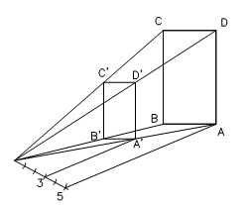  - Draw the given rectangle ABCD  - Mark a point any convenient distance from the figure  - Radiate lines from P to A, B, C and D.  - Divide PA into 5 equal parts  - Draw a line A’D’ from unit 3 (A1) parallel to AD.  - Draw C’D’ parallel to CD. Draw B’C’ parallel to BC. Draw B’A’ parallel to BA, to complete the reduced figure
Application | CLASS EXERCISE  - Construct the triangle given that AB=CD=50, AD=BC= 110  - Construct a similar figure with the sides reduced in the ratio of 3:5. | Questions And Answers | Provide answers
Conclusion | - Recap on the main steps and points | V/E
LESSON EVALUATION

TEACHER:MWALE CHIPO

KENNETH KAUNDA SECONDARY SCHOOL

DESIGN AND TECHNOLOGY DEPARTMENT
LESSON PLAN

SUBJECT: DESIGN AND TECHNOLOGY CLASS:…… … DATE:……/……./20…. DURATION:………….
BOYS:…………………… GIRLS ………………………………………. TOTAL OF PUPILS… TOPIC: PLANE FIGURES SUBTOPIC: REDUCTION OF PLANE FIGURES LEARNING OUTCOMES LSBAT
- To Reduce and enlarge plane figures

RATIONALE
Knowledge: Enlargement and reduction of plane figures by linear and area ratios.
Skills: Accuracy in enlarging and reducing plane figures
Values. Appreciation of reduction and enlargement of plane figures in designing.
TEACHING AIDS
……………………………………………………………………………………………………………………………………………

PART | LESSON CONTENT | METHODOLO GY | LEARNER ACTIVITY
introductio n | - Recap on the previous lesson | Questions and answers | Provide answers
Developme nt | RADIALS FROM A POLE NEAR THE CENTRE  TO REDUCE THE GIVEN POLYGON USING THE RATIO 3:5.  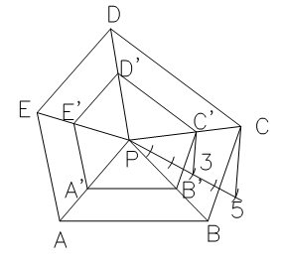  - Draw the given polygon ABCDE.  - Divide AB into 5 equal parts.  - Position pole P near the centre of the figure.  - Radiate lines from P to A, B, C and D.  - Draw a line to join 5B.  - Draw a parallel line to 5B at point 3 to have B’  xi. Draw B’C’ parallel to BC. Draw D’C’ parallel to DC. Draw D’E’ parallel to DE, Draw A’E’ parallel to AE, to complete the reduced figure
Application | CLASS EXERCISE  - Construct, full size, the polygon ABCDE given lengths of the sides to be; Base line AB = 70, BC = 60, CD = 40, DE= 65, AD = 60, and DAB = 900, ABC=1050.  - Construct a similar figure with the sides reduced in the ratio of 3:5. | Questions And Answers | Provide answers
Conclusion | - Recap on the main steps and points | V/E

TEACHER:MWALE CHIPO

KENNETH KAUNDA SECONDARY SCHOOL DESIGN AND TECHNOLOGY DEPARTMENT
LESSON PLAN

SUBJECT: DESIGN AND TECHNOLOGY CLASS:…… … DATE:……/……./20…. DURATION:………….
BOYS:…………………… GIRLS ………………………………………. TOTAL OF PUPILS… TOPIC: PLANE FIGURES SUBTOPIC: REDUCTION AND ENLARGEMENT LEARNING OUTCOMES LSBAT
- To Reduce and enlarge plane figures
RATIONALE
Knowledge: Enlargement and reduction of plane figures by linear and area ratios.
Skills: Accuracy in enlarging and reducing plane figures
Values. Appreciation of reduction and enlargement of plane figures in designing.
TEACHING AIDS
……………………………………………………………………………………………………………………………………………

PART | LESSON CONTENT | METHODOLO GY | LEARNER ACTIVITY
introductio n | - Recap on the previous lesson | Questions and answers | Provide answers
Developme nt | ENLARGEMENT AND REDUCTION OF PLANE FIGURE INVOLVING CENTRES OF ARCS  TO ENLARGE THE GIVEN DRAWING USING THE RATIO 3:5  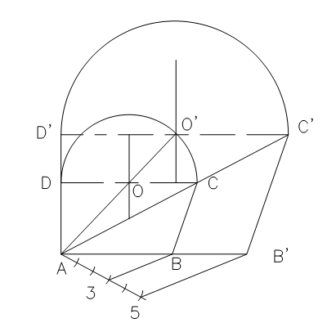  - Draw the given plane figures  - Extend line AB.  - Draw line of any convenient length and angle from B and Mark 3 equal units of any convenient length from A.  - Join 2 and B and draw a parallel line at point 3 to 2B.  - Radiate lines from A through C, O and D.  - Draw B’C’ parallel to BC. Draw C’D’ parallel to CD.  - Using the centre O’, draw the semicircle to complete the required figures.
 | CLASS EXERCISE  - Construct the triangle given that AB=40, AD= 30 and ABC=1050,  BAD=900  - Construct a similar figure with the sides increased in the ratio of 3:5. | Questions And Answers | Provide answers
Conclusion | - Recap on the main steps and points | V/E
LESSON EVALUATION

HOME WORK /EXAM QUESTIONS
PLANE FIGURES
- EQUAL AREAS
- REDUCTION AND ENLARGEMENT
Answer all the questions

Question 1
a. Construct, full size, the polygon ABCDE given lengths of the sides to be; Base line AB = 45, BC = 60, CD = 40, AC = 75, CE = 70, BE = 70, and AD = 60. [6]
- Construct a similar figure with the sides increased in the ratio of 4: 3. [5]
- Construct a square equal in area to that of the polygon drawn in (a). [8]
- Measure and state the size of the square. [1]

Question 2
- Construct the triangle ABC. BC=80, AB=60, CBA= 450
- Reduce the triangle ABC to a square having a similar area.
- Measure and state the length of side of the square to the nearest mm.

Question 3
- Construct a pentagon with sides 45 mm long. [7]
- By construction reduce the pentagon to a rectangle of equal area. [7]
- Construct from (b) a square equal in area to the rectangle. [5]
- Measure and state the size of the square. [1]

Question 4
- (i) Construct a triangle ABC standing on a base BC of length 110 mm with side AB of length 55 mm and angle BAC 90 °. [3]
(ii) Construct a square having an area equal to the triangle ABC and hence confirm its length of side is 51 mm. [8]
- Construct a regular pentagon whose sides are increased in the ratio of 3:4 to those of the square in part (a) (ii).[9]

Question 5
- Construct a triangle ABC such that side AB = 80 mm, the angle ACB = 52.5° and the ratio of the length of the sides AC: AB to be 2: 3. [14]
- Construct a square equal in area to twice that of the drawn triangle ABC. [6]

Question 6 (2016)
- Construct a triangle ABC whose perimeter is 180mm and its base angles are 52.50 and 600. [8]
- Using geometrical methods, construct a square equal in area to the triangle drawn in (a) above [8]
- Measure and state the length of the side of the square [1]
- Circumscribe a circle to a square drawn in (b) [3]

Question 7 (2007)
- Construct a regular heptagon of side 26 mm [6]
- Using geometrical contractions, reduce the heptagon drawn in (a) above to a rectangle equal in area. [6]
- Similarly transform the rectangle drawn in (b) above into a square equal in area [3]
- Circumscribe the square drawn in (c) above so that the circle touches the four corners of the square. [3]
- Measure and state the diameter of the circle to the nearest mm [3]

Question 8 (2013)
- Construct a quadrilateral given that: AB=70, AD=50, BAD=1050 , ABC=450, ADC=900 [5]
- Construct an enlarged quadrilateral so that its areas becomes twice the original figure [5]
- Transpose this enlarged figure in (b) to a square of equal area. [9]
- Measure and state the diagonal of the resulting square in (c) [1]

Question 9 (2017)
Triangle ABC is such that AB=100, AC=80 and angle ACB=450
- Construct the triangle
- Transpose the triangle in (a) to a square of equal area
- Inscribe a circle in the resulting square
- Measure and state the diameter of the circle. [20]

Question 10 (2011)
- Construct a regular heptagon in a circle of diameter of 70 mm [8]
- Transpose this heptagon into a square of equal area. [10]
- Measure and state the length of the sides of transposed square. [2]

